AUDISANKARA COLLEGE OF ENGINEERING & TECHNOLOGY (AUTONOMOUS)
A Capstone Project Report on

Performance Marketing
Submitted in a partial fulfillment for the award of the degree

BACHELOR OF TECHNOLOGY
In

COMPUTER SCIENCE AND ENGINEERING (ARTIFICIAL INTELLIGENCE)
SUBMITTED BY

MANNARUGUDI POOJITHA 22G21A3194 MONIKA.V 22G21A31A1
KOMMIREDDY VINAY KUMAR 22G21A3175 MOPURU SAI KRISHNA 22G21A31A2

Under the esteemed Guidance of
Dr. S.V. PADMAVATHI DEVI, Ph.D.,
Professor & Head, CSE(AI)


DEPARTMENT OF COMPUTER SCIENCE AND ENGINEERING (ARTIFICIAL INTELLIGENCE)
AUDISANKARA COLLEGE OF ENGINEERING & TECHNOLOGY(A)
Accredited by NAAC with ‘A+’ Grade | Accredited by NBA Approved by AICTE | Affiliated to JNTUA NH5 Bypass Road, Gudur – 524101, Tirupati (DT.), Andhra Pradesh

www.audisankara.ac.in
2026

AUDISANKARA COLLEGE OF ENGINEERING & TECHNOLOGY (AUTONOMOUS)
Accredited by NAAC with ‘A+’ Grade | Accredited by NBA Approved by AICTE | Affiliated to JNTUA
NH5 Bypass Road, Gudur – 524101, Tirupati (DT.), Andhra Pradesh

DEPARTMENT OF COMPUTER SCIENCE AND ENGINEERING (ARTIFICIAL INTELLIGENCE)


CERTIFICATE

This is to certify that the Full Semester Internship report on entitled “Performance Marketing"” is the Bonafide work done by the student MANNARUGUDI POOJITHA(22G21A3194), MONIKA.V(22G21A31A1),KOMMIREDDY VINAY KUMAR(22G21A3175),MOPURU SAI KRISHNA(22G21A31A2) in partial fulfillment of the requirements for the award of the degree of Bachelor of Technology in Computer Science and Engineering (Artificial Intelligence), from Jawaharlal Nehru Technological University Anantapur, Anantapuramu, during the year 2025-2026.

Project Guide Head of the Department

Mrs. S. CHANDANA KRISHNA, M. Tech.,
Assistant Professor, CSE-AI , Department of CSE(AI), ASCET, Gudur.
Dr. S.V. PADMAVATHI DEVI, Ph.D.,
Professor& Head, CSE-AI, Department of CSE(AI), ASCET. Gudur.

Submitted for the viva-voce Examination held on:

Internal Examiner External Examiner

AUDISANKARA COLLEGE OF ENGINEERING & TECHNOLOGY (AUTONOMOUS)
Accredited by NAAC with ‘A+’ Grade | Accredited by NBA Approved by AICTE | Affiliated to JNTUA
NH5 Bypass Road, Gudur – 524101, Tirupati (DT.), Andhra Pradesh


DECLARATION

We, MANNARUGUDI POOJITHA, M O N I K A . V , KOMMIREDDY VINAY KUMAR
REDDY, MOPURU SAI KRISHNA, hereby declare that the Project Work entitled Performance Marketing" done by us under the esteemed Guidance of MS. S. CHANDANA KRISHNA, M. Tech., Assistant Professor, Dept. of CSE(AI). The Capstone Project report is submitted in partial fulfillment of the requirements for the award of the bachelor’s degree in Computer Science and Engineering (Artificial Intelligence).

Date:

Place: Gudur

M.POOJITHA (22G21A3194) MONIKA.V (22G21A31A1)
K. VINAY KUMAR (22G21A3175) M.SAI KRISHNA (22G21A31A2)

ACKNOWLEDGMENT

We express our deepest gratitude to DR. VANKI PENCHALAIAH, Chairman of AUDISANKARA COLLEGE OF ENGINEERING & TECHNOLOGY, for providing us with an excellent academic environment and unwavering support throughout our project.
We extend our heartfelt thanks to SMT. VANKI ANUSHA, Vice Chairperson, for her encouragement and continuous motivation, which have been instrumental in our academic journey.
We sincerely appreciate the guidance and support of DR. J. AMARENDRA, Principal, whose leadership and vision have inspired us to strive for excellence.
We extend our sincere thanks to our project guide, Mrs. S. CHANDANA KRISHNA, M. Tech., Assistant Professor, Department of CSE (AI), for her valuable guidance, encouragement, and continuous support, which played a vital role in the successful completion of our project.
Our sincere gratitude goes to Dr. S. V. PADMAVATHI DEVI , Head of the Department-CSE(AI), for her valuable insights, motivation, and support, which greatly contributed to the successful completion of our project.
We are thankful to Dr. U. THIRUPALU, Department Project Coordinator, for his expert guidance and coordination, which played a key role in shaping our project.
We express our gratitude to our department faculty for their constant encouragement, technical guidance, and mentorship throughout this journey.

Our special thanks to the non-teaching faculty for their assistance and support in various aspects of our project work.
We would like to extend our heartfelt appreciation to our parents and friends, whose encouragement, patience, and moral support have been our driving force in completing this capstone project successfully.
Finally, we acknowledge the collaborative efforts of our team members, whose dedication and hard work made this project possible.

PROJECT ASSOCIATES

M.POOJITHA (22G21A3194)

MONIKA.V (22G21A31A1)

K.VINAY KUMAR (22G21A3175)

M.SAI KRISHNA (22G21A31A2)

CONTENTS

TITLE PAGE NO

ABSTRACT 10
LIST OF FIGURES 11
LIST OF TABLES 11
CHAPTER-1: INTRODUCTION 12-17
  - Introduction 12
  - Literature Survey 13
  - Objectives of the Project 14
  - Overview of the Thesis 15-17
CHAPTER-2: SYSTEM DESIGN & ARCHITECTURE 18-26
  - Introduction 18
  - Model Selection & Training 19-20
    - Introduction 19
    - Selection of NLP-Based Model 19
    - Resume and Job Description Matching 20
    - AI-Based Content Enhancement 20
    - Evaluation of the Model 20
  - AI-Based Resume Analysis and ATS Evaluation 20-21
    - Introduction 20-21
    - Keyword Extraction and Optimization 21
    - AI-Based Suggestions and Improvements 21
  - System Architecture 21-25
    - Introduction 21
    - Frontend and Backend Layer Architecture 22
    - Processing and Output Generation 22
    - System Workflow 23
    - Advantages of the Architecture 24
  - Limitations of the System 25-26
CHAPTER-3: METHODS & IMPLEMENTATION 27-33
  - Introduction 27
  - Resume Parsing and Text Extraction 27-28
  - Natural Language Processing Techniques 28-29
    - Introduction 28
    - Tokenization and Text Normalization 28
    - Keyword Extraction 29
  - Resume and Job Description Matching and ATS Evaluation 29
    - Introduction 29
    - Keyword Matching and Score Calculation 29
  - AI-Based Resume Enhancement 30
    - Introduction 30
    - Grammar Correction & Professional Content Generation 30
  - Resume Builder Module 31
    - Introduction 31
    - Resume Generation Process 31
  - System Workflow 32
  - Conclusion 33
CHAPTER-4: MODULES / COMPONENTS 34-43
  - Introduction 34-35
  - Frontend User Interface & UX Design 35
    - Introduction 35
    - User Interaction & Resume Upload Interface 35
    - Resume Builder Interface 36
  - Backend Processing Module 37
    - Introduction 37
    - FastAPI AI Integration & Request Handling 37
  - Resume Pursing & Text Extraction Module 38-39
    - Introduction 38
    - File Format Detection 38
    - Text Extraction Process 38
    - Data Cleaning & Pre Processing 39
  - Resume Analysis & ATS Evaluation Module 39-40
    - Introduction 39
    - Keyword Analysis & ATS Evaluation 39
    - AI-Based Suggestions 40
  - Resume Builder & Document Generation Module 40-41
    - Introduction 40
    - User Input and Resume Generation 41
    - PDF & DOCX Generation 41
  - Advantages Of Modular Architecture 43
  - Conclusion 43
CHAPTER-5: SIMULATION RESULTS & DISCUSSIONS 44-55
  - Introduction 44
  - System Testing Environment 44
    - Resume Analysis & ATS Evaluation 44
    - Resume Generation Testing 45
  - User5.3.6 Interface Results 45
    - Home Page 45
    - Resume Upload Page 45
    - Result Page 46
    - Resume Builder Page 46
    - Resume Parsing Result 46
    - ATS Score Results 46
    - Job Descrption Matching Results 47
  - Results 54
  - Advantages and Limitations of The System 55
  - Future Enhancements 55
CHAPTER-6: CONCLUSION & FUTURE SCOPE 56-58
  - Conclusion 56-57
  - Future Scope 57-58
REFERENCES 59
BIOGRAPHIES 60

ABSTRACT
The rapid advancement of Artificial Intelligence (AI) has significantly transformed the recruitment and hiring landscape, particularly in the domain of resume screening and candidate evaluation. In today’s competitive job market, organizations rely heavily on Applicant Tracking Systems (ATS) to filter and shortlist candidates based on their resumes. However, many job seekers struggle to create resumes that effectively align with job descriptions and meet ATS requirements, leading to missed opportunities despite having relevant skills and qualifications. This project presents the design and development of an AI-based Resume Analyzer and Builder system that aims to bridge the gap between job seekers and modern recruitment systems. The proposed system is a web-based application developed using Fast API that enables users to upload their resumes in multiple formats such as PDF, DOCX, and TXT, and analyze them against specific job descriptions. The system leverages Natural Language Processing (NLP) techniques and AI-driven content analysis to extract relevant information, evaluate keyword alignment, and generate detailed feedback. Additionally, the system provides ATS compatibility scores and job matching percentages, helping users understand how well their resumes fit the requirements of a given job role. A key feature of this project is the integration of a resume builder module that allows users to create professional resumes from scratch by entering structured data such as personal details, skills, education, experience, and projects. The system enhances this data using AI-based content generation techniques to produce well-formatted, grammatically correct, and industry-standard resumes. The generated resumes can be downloaded in both PDF and DOCX formats, ensuring flexibility and usability. Overall, this project contributes to the field of AI- driven recruitment solutions by offering an integrated platform that combines resume analysis, job matching, and resume generation, thereby improving the efficiency and effectiveness of the job application process.

LIST OF FIGURES

Figure 1: Workflow Of AI Based Resume Analyzer & Builder System Figure 2: ATS Based Resume Screening Process
Figure 3: Workflow Of AI Based Resume Analyzer & Builder System Figure 4: Workflow Of Resume & Job Description Analysis System Figure 5: Resume Upload & Resume Creation Interface
Figure 6: Resume Document Generation & PDF Conversion Process Figure 7: Resume Upload & Analysis Interface
Figure 8: Resume Processing & Analysis Interface
Figure 9: AI Based Resume Analysis & Suggestion Interface Figure 10: Updated Resume Download Interface
Figure 11: Job Description Matching & Resume Evaluation Interface Figure 12: Quick ATS Resume Scan Result Interface
Figure 13: Professional Resume Builder Interface Figure 14: Resume Generation & Download Interface

LIST OF TABLES

Tabel 1: Resume Matching Parameters
Table 2: AI Based Resume Enhancement Features
Table 3: System Workflow Description Table 4: Resume Analysis Features Table 5: Functional Testing Results Table 6: System Performance Analysis
Table 7: Comparisons with Existing Systems

CHAPTER-1: INTRODUCTION

Introduction

The emergence of Artificial Intelligence (AI) and its integration into various domains has revolutionized traditional processes, particularly in the field of recruitment and talent acquisition. In modern hiring practices, organizations increasingly rely on automated systems such as Applicant Tracking Systems (ATS) to filter and evaluate resumes before they reach human recruiters. These systems analyze resumes based on keywords, formatting, and relevance to job descriptions, significantly reducing the time and effort required in the recruitment process. However, this shift has also introduced new challenges for job seekers, who must now ensure that their resumes are not only professionally written but also optimized for machine-based evaluation systems.

In this context, the development of intelligent tools that assist users in creating and optimizing resumes has become increasingly important. Many candidates, especially fresh graduates and early-career professionals, lack the knowledge and expertise required to tailor their resumes according to specific job requirements. As a result, they often fail to pass the initial screening stages, despite possessing the necessary skills and qualifications. This highlights the need for a system that can analyze resumes, provide actionable feedback, and guide users in improving their profiles effectively.

The proposed AI-based Resume Analyzer and Builder system addresses these challenges by leveraging advanced technologies such as Natural Language Processing (NLP), machine learning, and web-based application frameworks. The system is designed to analyze resumes by extracting textual content, identifying key skills and keywords, and comparing them with job descriptions provided by the user. Based on this analysis, the system generates detailed suggestions, matching scores, and ATS compatibility metrics, enabling users to understand their strengths and areas for improvement.

Furthermore, the system includes a resume builder module that allows users to create professional resumes from structured input data. This module utilizes AI-driven content enhancement techniques to refine the input, ensuring that the final resume is well-organized, grammatically correct, and aligned with industry standards. By combining analysis and generation capabilities, the system provides a comprehensive solution for resume optimization.

Literature Survey

    - Resume Parsing and Information Extraction

Resume parsing is an important process in modern recruitment systems, where information such as skills, education, and experience is automatically extracted from resumes. Many organizations use automated systems to reduce manual effort and improve recruitment efficiency. Natural Language Processing (NLP) techniques are commonly used to process unstructured resume data and convert it into structured information. Research in this area has improved the accuracy of extracting relevant candidate details from multiple file formats. This concept forms the foundation for AI-based resume analysis systems.

Applicant Tracking Systems (ATS)

Applicant Tracking Systems are widely used by companies to filter and shortlist resumes during recruitment. These systems analyze resumes based on keywords, formatting, and relevance to job descriptions. Candidates whose resumes are not ATS-friendly are often rejected before reaching recruiters. Research on ATS systems highlights the importance of proper resume formatting and keyword optimization. The proposed project focuses on improving ATS compatibility using AI- driven analysis.

Natural Language Processing in Recruitment

Natural Language Processing plays a significant role in analyzing textual informatresumes and job descriptions. NLP techniques help identify important skills, qualifications, and experience from unstructured text. Modern recruitment systems use semantic analysis to understand the meaning of words instead of relying only on keyword matching. Researchers have developed several NLP models to improve resume-job matching accuracy. These techniques help recruitment systems make better hiring decisions.

AI-Based Resume Recommendation Systems

AI-based recommendation systems provide suggestions to improve resume quality and relevance. These systems analyze candidate profiles and identify missing keywords or weak content. Many platforms use machine learning models to generate personalized feedback for users. Research shows that AI-driven suggestions significantly improve resume effectiveness and increase interview opportunities. The proposed system integrates AI techniques to generate detailed improvement suggestions for resumes.

Job Description Matching Techniques

Job description matching is an important feature in modern recruitment platforms. It involves comparing resume content with job requirements to calculate similarity scores. Traditional systems use keyword matching, while advanced systems use semantic similarity and machine learning approaches. Research in this field focuses on improving matching accuracy and reducing false results. The proposed project uses AI-based analysis to provide accurate resume-job matching scores

Objectives of the Project

    - Development of AI-Based Resume Analyzer

The primary objective of the project is to develop an intelligent resume analysis system using Artificial Intelligence techniques. The system should analyze resumes and provide meaningful feedback to users. It aims to help candidates improve resume quality and increase their chances of selection. The analyzer should identify strengths and weaknesses in resumes effectively. This objective forms the core functionality of the project.

Resume and Job Description Matching

Another important objective is to compare resumes with job descriptions and calculate matching scores. The system should identify relevant skills and keywords that align with job requirements. This helps users understand how suitable their resume is for a particular role. Accurate matching improves the effectiveness of job applications.

ATS Compatibility Evaluation

The project aims to evaluate resumes based on ATS compatibility standards. Many resumes fail because they are not optimized for automated screening systems. The proposed system should analyze formatting, keywords, and structure to generate ATS scores. This helps users create resumes that can pass automated filters successfully. ATS optimization is essential in modern recruitment processes.

Automated Resume Generation

The system also aims to provide an automated resume builder for users. Candidates can enter their details such as education, skills, and experience to generate professional resumes. AI techniques are used to improve grammar, formatting, and presentation. The generated resumes should follow industry standards and professional layouts. This feature simplifies resume creation for users.

User-Friendly and Scalable System

The final objective is to develop a user-friendly and scalable web application. The system should provide smooth interaction and fast processing for multiple users. It should support different resume file formats such as PDF, DOCX, and TXT. The application must also ensure reliability, efficiency, and future scalability. A simple and accessible interface improves user experience significantly

Overview of the Thesis

This thesis presents the design, development, and evaluation of an AI-based Resume Analyzer and Builder system, which aims to assist job seekers in improving their resumes and increasing their chances of selection in modern recruitment processes. The system integrates advanced technologies such as Natural Language Processing (NLP), machine learning, and web-based frameworks to analyze resumes, match them with job descriptions, and generate professional resumes. The thesis is structured into multiple chapters, each focusing on a specific aspect of the system, from conceptual understanding to implementation and evaluation.

Chapter1: Introduction

This chapter provides a comprehensive overview of the project, including the background, motivation, and significance of the study. It discusses the challenges faced by job seekers in creating ATS-friendly resumes and highlights the increasing reliance on automated recruitment systems. The chapter also defines the problem statement and outlines the objectives of the project. Additionally, it introduces the proposed solution, explaining how the AI-based Resume Analyzer and Builder system addresses the limitations of existing tools. The scope of the project and its potential impact on job seekers and recruiters are also discussed in detail.

Chapter2: System Design and Architecture

This chapter focuses on the overall design and architecture of the system. It describes the structural components of the application, including the frontend interface, backend processing using Fast API, and the integration of AI-based modules. The chapter explains how different components interact with each other to process user input and generate outputs efficiently. It also discusses the technical challenges encountered during system development, such as handling multiple file formats, processing unstructured data, and ensuring scalability. Furthermore, the chapter presents architectural diagrams, flowcharts, and data flow representations to provide a clear understanding of the system workflow.

Chapter 3: Methods and Implementation

This chapter provides a detailed explanation of the methodologies and techniques used in the development of the system. It covers the algorithms and processes involved in resume analysis, job description matching, and AI-based content enhancement. The chapter discusses the use of Natural Language Processing techniques for extracting and analyzing textual data, as well as the implementation of scoring mechanisms for evaluating resume relevance. It also explains the technical implementation of various modules, including file handling, text extraction, and AI-based content generation. The integration of these components into a cohesive system is described in detail.

Chapter 4: Modules and Components

This chapter outlines the different modules that constitute the system and explains their functionalities. It provides a detailed description of each module, including the resume analyze module, job matching module, resume builder module, file generation module, and user history module. The interactions between these modules are also discussed, highlighting how they work together to deliver the overall functionality of the system. The chapter emphasizes the modular design approach, which allows for flexibility, scalability, and ease of maintenance.

Chapter 5: Results and Discussion

This chapter presents the results obtained from testing and evaluating the system. It includes an analysis of the system’s performance, accuracy, and efficiency in processing resumes and generating outputs. The chapter also discusses user feedback and observations, highlighting the strengths and limitations of the system. Comparative analysis with existing tools may also be included to demonstrate the effectiveness of the proposed solution. The results are supported by screenshots, tables, and graphs to provide a clear understanding of the system’s performance.

Chapter 6: Conclusion and Future Scope

This chapter summarizes the key findings of the project and evaluates the extent to which the objectives have been achieved. It highlights the contributions of the system in improving resume quality and enhancing job matching capabilities. The chapter also discusses the limitations of the current system and suggests potential areas for future improvement. These may include the integration of advanced AI models, addition of database support, real-time job recommendations, and enhanced user personalization features.

CHAPTER-2: SYSTEM DESIGN & ARCHITECTURE

Introduction

The design and architecture of an AI-based system play a critical role in determining its efficiency, scalability, and usability. In the context of the AI-based Resume Analyzer and Builder system, the architecture is designed to handle multiple functionalities, including resume parsing, job description analysis, AI-based content enhancement, and file generation. The system is developed as a web-based application using a modular and scalable architecture that ensures smooth interaction between different components.

The primary goal of the system architecture is to provide a seamless experience for users while efficiently processing complex operations such as text extraction, natural language processing, and AI-driven content generation. The system must be capable of handling multiple user requests simultaneously while maintaining performance and accuracy. To achieve this, the architecture is divided into several layers, including the presentation layer, application layer, processing layer, and output layer.

The presentation layer consists of user interfaces developed using HTML templates, which allow users to upload resumes, enter job descriptions, and interact with the system. The application layer, implemented using Fast API, handles incoming requests, processes user input, and coordinates with backend modules. The processing layer performs core functionalities such as text extraction, resume analysis, and AI-based enhancements. Finally, the output layer generates results, including analysis reports and downloadable resume files.

The system is designed to be flexible and extensible, allowing for future enhancements such as integration with external job portals, advanced AI models, and database storage systems. By adopting a modular architecture, the system ensures that individual components can be updated or replaced without affecting the overall functionality. Security is also a critical consideration in the system architecture. Since the application handles user-uploaded resumes, which may contain sensitive personal information, appropriate measures are implemented to ensure data privacy and protection.These measures include input validation, secure file handling, and restricted access to system resources.

Security is also a critical consideration in the system architecture. Since the application handles user- uploaded resumes, which may contain sensitive personal information, appropriate measures are implemented to ensure data privacy and protection. These measures include input validation, secure

file handling, and restricted access to system resources.
In summary, the system design and architecture of the AI-based Resume Analyzer and Builder are carefully structured to provide a robust, scalable, and user-friendly platform. By integrating multiple layers and modules, the system ensures efficient processing of user inputs, accurate analysis of resumes, and generation of high-quality outputs. The architectural approach not only addresses current requirements but also lays the foundation for future enhancements, making the system adaptable to evolving technological advancements and user needs.

Model Selection & Training

Introduction

Model selection and training are important stages in the development of the AI-based Resume Analyzer and Builder system. The efficiency and accuracy of the application depend on how effectively the selected model processes resume data and job descriptions. Since resumes mainly contain unstructured textual information, Natural Language Processing (NLP) techniques are used for analysis and processing. The system is designed to analyze resume content, identify important keywords, and generate meaningful suggestions for users. Proper model selection ensures better performance, scalability, and reliability of the application.

Selection of NLP-Based Model

The project uses NLP-based text analysis techniques because they are effective in processing textual data present in resumes and job descriptions. The selected model focuses on extracting skills, qualifications, and experience details from resumes. NLP models help in understanding sentence structure, identifying keywords, and comparing textual similarity between resumes and job descriptions. These techniques improve the accuracy of resume evaluation and ATS compatibility analysis. The model was selected based on factors such as processing speed, accuracy, and ease of integration with the Fast API framework.

    - Resume and Job Description Matching

The selected model performs resume-job matching using keyword analysis and text similarity techniques. The system compares the skills and qualifications mentioned in the resume with those specified in the job description. It calculates a matching score based on the relevance of keywords and phrases. Semantic analysis techniques are also considered to improve matching accuracy by understanding contextual meaning instead of relying only on exact keyword matches. This helps users identify gaps in their resumes and improve alignment with job requirements.

AI-Based Content Enhancement

The system also includes AI-based content enhancement techniques to improve resume quality. The model identifies weak or incomplete sections in resumes and generates suggestions for improvement. Grammar correction, formatting optimization, and professional wording are applied to make resumes more ATS-friendly and industry-standard. AI-generated suggestions help users present their skills and experience more effectively. This feature improves the overall quality and readability of resumes.

Evaluation of the Model

The model is evaluated based on the accuracy of resume analysis, job matching scores, and quality of generated suggestions. Different test cases are used to analyze how effectively the system identifies keywords and evaluates resume relevance. The evaluation process helps identify limitations and areas for improvement. User feedback is also considered to improve the quality and reliability of the system. Continuous evaluation ensures better performance and future scalability.

AI-Based Resume Analysis and ATS Evaluation

Introduction

AI-based resume analysis is one of the most important features of the proposed system. The system uses Artificial Intelligence and Natural Language Processing techniques to analyze resume content

and evaluate its quality. Modern recruitment companies use Applicant Tracking Systems (ATS) to filter resumes before they are reviewed by recruiters. Therefore, resumes must be optimized according to ATS requirements. The proposed system helps users improve their resumes by providing AI-generated feedback and ATS compatibility scores.

    - Keyword Extraction and Optimization

The system extracts important keywords from both resumes and job descriptions to improve matching accuracy. These keywords mainly include technical skills, programming languages, qualifications, and domain-specific terms. The extracted keywords are compared with job requirements to identify missing or weak areas in the resume. Users can optimize their resumes by including relevant keywords naturally in their content. Keyword optimization improves ATS performance and increases the probability of selection.

    - AI-Based Suggestions and Improvements

The system generates AI-based suggestions to improve the overall quality of resumes. These suggestions include grammar correction, formatting improvements, professional wording, and content enhancement. Weak sections in resumes are identified and rewritten using better action- oriented language. The AI-generated recommendations help users create resumes that are more professional and impactful. This feature simplifies the resume improvement process significantly.

System Architecture

Introduction

System architecture defines the overall structure, organization, and interaction between different components of the AI-Based Resume Analyzer and Builder system. It explains how the frontend interface, backend server, processing modules, and output generation components work together to perform resume analysis and resume generation functionalities efficiently.

Frontend and Backend Layer Architecture
The frontend layer acts as the user interface of the application. It is responsible for collecting user input such as resume uploads, job descriptions, and resume builder information. HTML templates and static files are used to design the interface and improve user interaction. The frontend communicates with the backend server through API requests and displays the generated results to users. A user-friendly interface ensures easy navigation and accessibility for both technical and non- technical users.

The backend layer is developed using the Fast API framework and serves as the core processing unit of the application. It handles incoming requests from users and coordinates communication between different modules. The backend validates uploaded files, extracts textual content, performs analysis, and generates responses. Fast API is selected because of its high performance, asynchronous request handling, and easy integration with Python libraries. This layer ensures efficient processing and smooth system functionality.

Processing and Output Generation

The processing layer performs the main functionalities of the application. It includes resume parsing, text extraction, keyword analysis, job description matching, and AI-based content enhancement. Natural Language Processing techniques are used to process unstructured textual data from resumes and job descriptions. The system evaluates ATS compatibility and generates meaningful suggestions for users. This layer acts as the intelligence component of the application.

The output generation layer is responsible for presenting analysis results to users. It displays ATS scores, job matching percentages, and AI-generated improvement suggestions. The system also generates professional resumes in PDF and DOCX formats for download. Results are displayed in a structured and user-friendly format to help users understand their resume performance easily. This layer improves usability and enhances overall user experience.

System Workflow

The workflow of the system begins when a user uploads a resume or enters details into the resume

builder module. The frontend sends this information to the backend server through API requests. The backend processes the data using NLP and AI-based techniques, performs analysis, and calculates scores. The generated results are then sent back to the frontend for display. Finally, users can download improved resumes and review analysis reports generated by the system.

The extracted content is processed using Natural Language Processing methods for keyword extraction, resume analysis, and ATS evaluation. The system compares resume content with the provided job description and calculates matching scores based on keyword relevance and content similarity. AI-based suggestions are generated to improve grammar, formatting, and resume quality.

Once analysis is completed, the generated ATS score, matching percentage, and improvement suggestions are displayed to the user through the frontend interface. The resume builder module also enables users to generate professional resumes in PDF and DOCX formats. The workflow ensures efficient processing and improves the overall usability of the application.

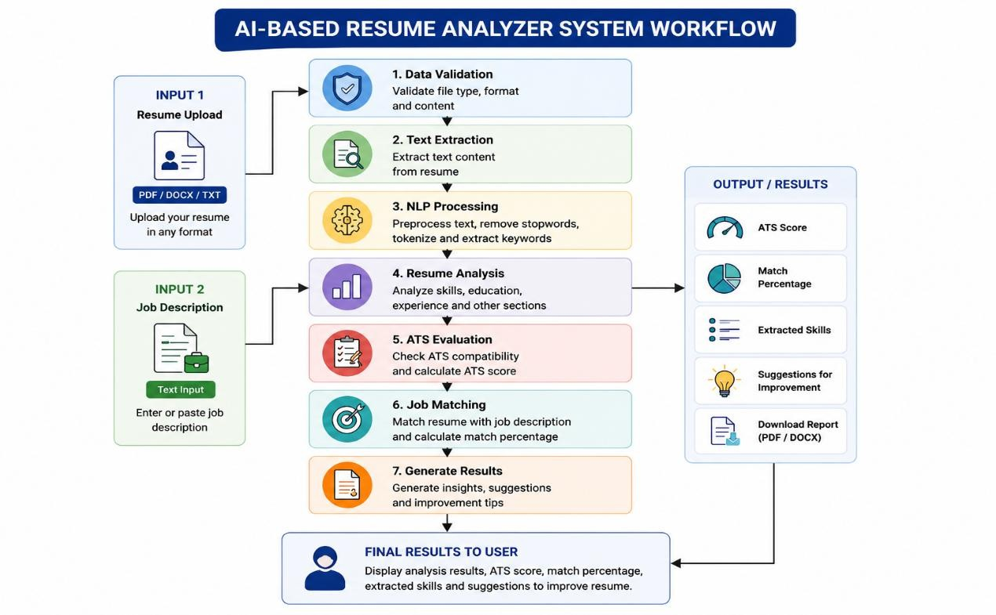

Figure 2.1: Workflow of AI-Based Resume Analyzer and Builder System

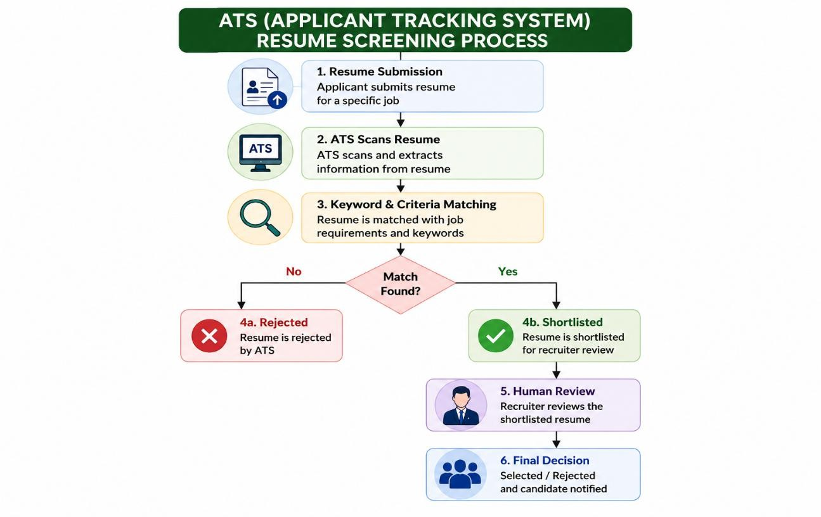

Figure 2.2: ATS-Based Resume Screening Process

Advantages of the Architecture

The proposed architecture provides several advantages such as modularity, scalability, and flexibility. Individual modules can be modified or upgraded without affecting the entire system. Fast API ensures high-speed processing and efficient handling of multiple requests. The layered architecture improves maintainability and simplifies debugging and future enhancements. Overall, the architecture provides a strong foundation for developing a reliable and scalable AI-based Resume Analyzer and Builder application.

Another important advantage is the integration of multiple functionalities into a single platform. Users can analyze resumes, compare them with job descriptions, receive AI-based suggestions, and

generate professional resumes without using separate applications. The support for multiple file formats such as PDF, DOCX, and TXT improves flexibility and usability.
The FastAPI-based backend architecture ensures high-speed processing and efficient request handling. The modular structure of the application also improves scalability and maintainability, allowing future enhancements to be implemented easily. Overall, the system provides an intelligent and user-friendly solution for resume optimization and recruitment support.

Limitations of the System

Although the proposed system performs effectively, certain limitations still exist. The current implementation mainly supports resumes written in English and may not process multilingual resumes efficiently. The ATS evaluation mechanism is based on predefined analysis techniques and may vary from actual recruitment systems used by companies.
The system also depends on the quality of uploaded resumes and job descriptions for generating accurate results. Resumes with poor formatting or incomplete information may reduce analysis accuracy. In addition, the current version of the application uses limited AI-based semantic analysis techniques compared to advanced commercial recruitment systems.

Another limitation is the absence of permanent database storage for user data and resume history. The system currently focuses on core functionalities such as resume analysis, ATS evaluation, and resume generation. Future improvements can address these limitations using advanced NLP models, database integration, and cloud-based deployment solutions.

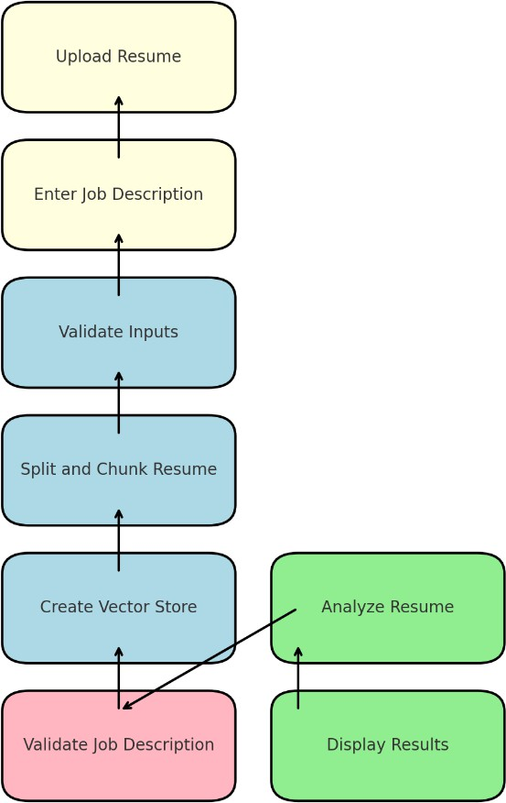

Figure 2.1: Workflow of AI-Based Resume Analyzer and Builder System

CHAPTER-3: METHODS & IMPLEMENTATION

Introduction

This chapter explains the methods, techniques, and implementation procedures used in the development of the AI-based Resume Analyzer and Builder system. The system is developed to analyze resumes, compare them with job descriptions, evaluate ATS compatibility, and generate professional resumes using Artificial Intelligence and Natural Language Processing techniques. The implementation process involves several stages such as file handling, text extraction, preprocessing, resume analysis, keyword matching, AI-based content enhancement, and output generation.

The main objective of this chapter is to describe how the proposed system processes user input and converts unstructured textual data into meaningful information. Different algorithms and techniques are integrated into the system to improve accuracy, efficiency, and scalability. The chapter also explains the technologies and frameworks used for implementation, including Fast API, NLP techniques, and AI-based text processing methods.

The proposed system follows a modular implementation approach where each component performs a specific task independently. This approach improves maintainability, scalability, and overall system performance. The implementation methodology ensures smooth interaction between frontend and backend components while maintaining fast response time and reliable processing.

Resume Parsing and Text Extraction

    - Introduction

Resume parsing is the process of extracting useful information from resumes uploaded by users. Since resumes are available in different formats such as PDF, DOCX, and TXT, the system must handle multiple file types efficiently. Text extraction is an important stage because all further analysis depends on the quality and accuracy of extracted data.

File Upload and Text Extraction Process
before processing to ensure that only supported formats are accepted. The validation mechanism prevents unsupported or corrupted files from entering the system. This improves reliability and security during file processing . The text extraction module converts uploaded resumes into plain textual content. Different extraction techniques are used based on the file format. PDF files require parsing methods to extract textual information from complex layouts, while DOCX files are processed using document-reading libraries. TXT files are directly read as plain text.
The extracted content includes:
      - Personal information
      - Skills
      - Education
      - Experience
      - Certifications
      - Projects
This extracted text becomes the input for further NLP-based analysis.

Natural Language Processing Techniques

Introduction

Natural Language Processing (NLP) is one of the core technologies used in the proposed system. NLP techniques help the application understand, process, and analyze textual information present in resumes and job descriptions. These techniques improve keyword extraction, text similarity analysis, and semantic understanding.

Tokenization and Text Normalization

Tokenization is the process of dividing textual data into smaller units called tokens. These tokens may include words, phrases, or sentences. Tokenization helps the system process resume content efficiently and identify important terms related to job requirements. Stop words are commonly used words such as “the,” “is,” and “and,” which do not contribute significantly to analysis. The system removes stop words during preprocessing to improve efficiency and focus on meaningful keywords. Text normalization converts textual data into a standard format. This includes converting text into lowercase, removing special symbols, and correcting formatting issues. Normalization improves consistency and analysis accuracy.

Keyword Extraction

Keyword extraction identifies important technical and professional terms from resumes and job descriptions. These keywords include:
      - Programming languages
      - Technical skills
      - Certifications
      - Tools and technologies
Extracted keywords are used for job matching and ATS evaluation.

Resume and Job Description Matching and ATS Evaluation

Introduction

Job description matching is one of the main functionalities of the system. It compares resume content with job requirements to calculate a relevance score. This helps users understand how well their resumes align with specific job roles.

Keyword Matching and Score Calculation

The system compares keywords present in resumes and job descriptions. Matching keywords increase the relevance score, while missing keywords reduce it. This process helps identify skill gaps and areas for improvement. The system calculates a matching percentage based on:
      - Number of matching skills
      - Relevance of experience
      - Keyword frequency
      - Resume structure
The generated score helps users evaluate resume suitability for a particular job role.

TABLE 3.1: Resume Matching Parameters

Parameter | Description
Skills Matching | Compares technical skills
Keyword Frequency | Counts relevant keywords
Experience Relevance | Checks work experience alignment
Education Match | Evaluates qualification relevance
ATS Compatibility | Checks formatting and structure

AI-Based Resume Enhancement

Introduction

AI-based enhancement improves the quality and professionalism of resumes. The system generates suggestions for grammar correction, formatting improvement, and professional wording.

Grammar Correction and Professional Content Generation

The AI model identifies grammatical errors and formatting inconsistencies in resumes. Suggested corrections improve readability and professionalism. The system rewrites weak resume content using professional and action-oriented language. This helps users present their skills and achievements more effectively.
The system organizes resume sections such as education, skills, and experience in a professional format. Proper structuring improves readability and ATS compatibility.

TABLE 3.2: AI-Based Resume Enhancement Features

Feature | Purpose
Grammar Correction | Removes language errors
Keyword Optimization | Improves ATS compatibility
Formatting Improvement | Enhances readability
Professional Rewriting | Improves content quality
Resume Structuring | Organizes resume sections

Resume Builder Module

Introduction

The resume builder module enables users to create professional resumes from structured input data. Users can enter personal information, skills, projects, and experience through forms.

Resume Generation Process

The system collects:
      - Personal details
      - Skills
      - Education
      - Experience
      - Projects
      - Certifications

This information is processed and converted into a structured resume format.The collected information is formatted into professional resume templates. AI techniques improve wording and formatting before generating the final output.The final resumes are generated in PDF and DOCX formats. This provides flexibility and convenience for users during job applications.

System Workflow

The system workflow begins with resume upload or user data entry. The uploaded resume is validated and converted into plain text. NLP techniques analyze the text and compare it with the job description. ATS scores and suggestions are generated based on the analysis. Finally, users can download professional resumes generated by the system.

Table 3.3: System Workflow Description

Step | Process | Output
1 | Resume Upload | Resume File
2 | Text Extraction | Extracted Text
3 | NLP Analysis | Keywords Identified
4 | ATS Evaluation | ATS Score
5 | Job Matching | Matching Percentage
6 | AI Suggestions | Resume Improvements
7 | Resume Generation | PDF/DOCX Resume

The Resume Builder module allows users to create professional resumes using structured forms and predefined templates. Users can enter personal details, education, skills, projects, certifications, and work experience to generate well-formatted resumes.

Finally, the Output Generation module displays ATS scores, analysis results, matched skills, missing keywords, and AI-based suggestions to users. The system also generates downloadable resumes in PDF and DOCX formats. The overall workflow ensures efficient resume analysis, optimization, and professional document generation within a single platform.

System Workflow Diagram

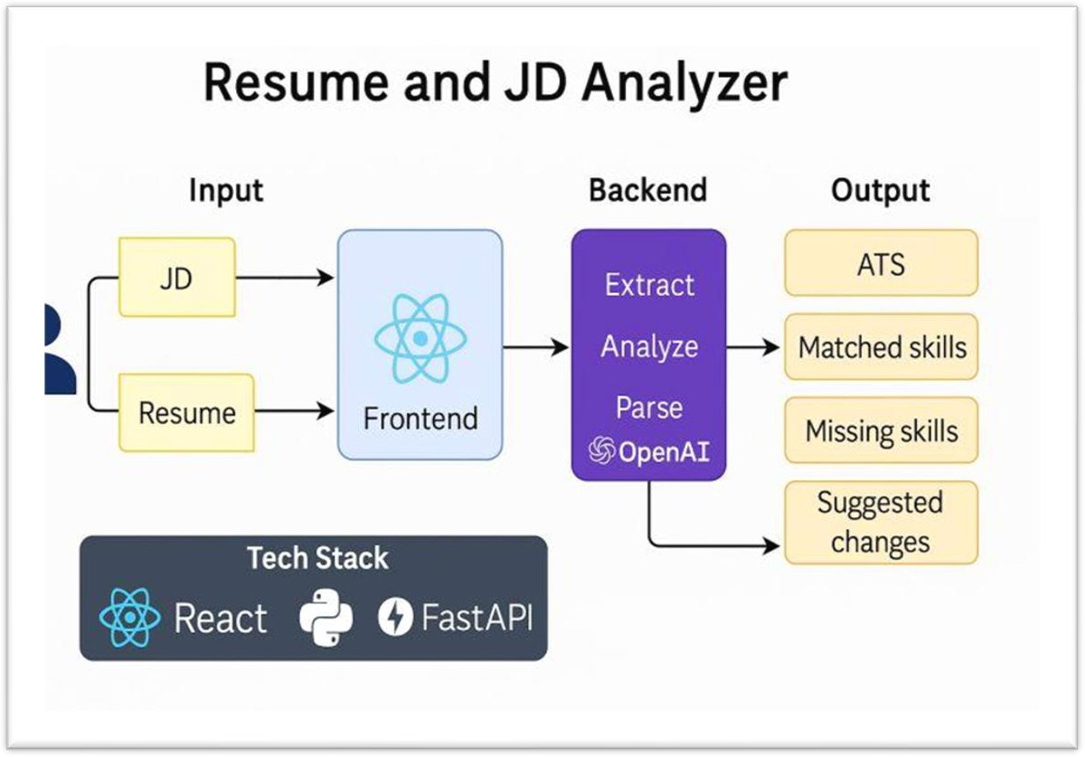

Figure 3.1: Workflow of Resume and Job Description Analysis System

Conclusion

This chapter explained the methods and implementation techniques used in the AI-based Resume Analyzer and Builder system. Different modules such as text extraction, NLP processing, job matching, ATS evaluation, and AI-based content enhancement work together to provide meaningful analysis and professional resume generation. The use of Fast API ensures efficient backend processing and smooth communication between components. Overall, the proposed methodology provides a scalable and intelligent solution for resume optimization and job matching.

Chapter 4: Modules / Components

Introduction

The AI-based Resume Analyzer and Builder system is developed using a modular architecture where each module performs a specific function independently while interacting with other modules to achieve the overall functionality of the application. The modular design improves scalability, maintainability, flexibility, and system performance. Each component of the system is carefully designed to handle a particular task such as resume upload, text extraction, resume analysis, ATS evaluation, AI-based content enhancement, and resume generation.

The system consists of both frontend and backend components that work together to provide a seamless user experience. The frontend layer is responsible for collecting user input and displaying analysis results, while the backend layer handles processing, AI-based analysis, and file generation. The modular approach also allows future enhancements and easy integration of additional functionalities without affecting the overall architecture of the application.

This chapter explains the different modules and components of the proposed system in detail, including their functionalities, implementation process, and significance in the overall workflow of the application.

The resume builder module allows users to generate resumes from scratch by entering details such as education, experience, projects, certifications, and technical skills. The collected information is formatted into professional templates and converted into downloadable PDF and DOCX files. This feature is especially beneficial for students and fresh graduates who may not have prior experience in creating professional resumes.

The system also includes a user history and tracking module that stores previous analysis results and generated resumes temporarily. This allows users to review their earlier activities and track improvements in resume quality over time. Session management techniques are used to maintain separate histories for different users securely.

In addition to functionality, the proposed system focuses on performance, scalability, and reliability. The Fast API framework enables efficient request handling and asynchronous processing, allowing the system to support multiple users simultaneously without performance degradation. Proper validation and error-handling mechanisms are also implemented to ensure secure and stable operation of the application.

Overall, the AI-based Resume Analyzer and Builder system provides a comprehensive and intelligent solution for modern resume management. By integrating AI, NLP, ATS evaluation, and professional resume generation into a single platform, the system helps users improve resume quality, optimize job applications, and enhance their opportunities in the recruitment process.

Frontend User Interface Module

Introduction

The frontend user interface module acts as the interaction layer between users and the system. It is designed to provide a simple, responsive, and user-friendly environment where users can upload resumes, enter job descriptions, and generate professional resumes. A well-designed interface improves usability and ensures smooth navigation throughout the application.

User Interaction and Resume Upload Interface

The frontend interface includes multiple pages such as:
      - Home Page
      - Resume Upload Page
      - Resume Builder Page
      - Result Page
      - History Page
Users can easily navigate between these sections to access different functionalities. The interface is designed using HTML templates and static styling components to provide a clean and professional appearance. Proper navigation improves accessibility and enhances user experience.The resume upload section allows users to upload resumes in PDF, DOCX, and TXT formats. The interface validates uploaded files and displays error messages for unsupported formats. This module ensures smooth interaction between users and the backend processing system.

The upload interface is designed to minimize complexity and simplify the resume submission process.

Resume Builder Interface

The resume builder interface enables users to enter structured information such as:
      - Personal details
      - Skills
      - Education
      - Experience
      - Projects
      - Certifications

The collected information is sent to the backend for processing and resume generation. This interface simplifies resume creation for users who do not already have a professional resume prepared.

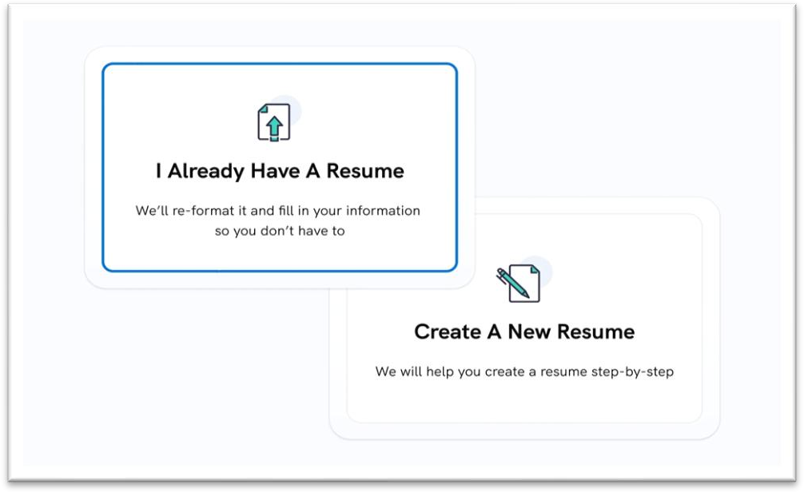

Figure 4.1: Resume Upload and Resume Creation Interface

Backend Processing Module

Introduction

The backend processing module acts as the core component of the system. It is responsible for handling requests, processing uploaded resumes, performing analysis, and generating outputs. The backend is implemented using the FastAPI framework because of its high performance and efficient request handling capabilities.

FastAPI Framework Integration and Request Handling

FastAPI is selected for backend development due to its asynchronous programming support and scalability. It efficiently handles multiple user requests simultaneously and provides faster response times. The framework also simplifies API development and integration with Python-based NLP libraries.
The backend manages:
      - File uploads
      - Resume parsing
      - Text extraction
      - Resume analysis
      - ATS score generation
      - PDF/DOCX generation
This modular backend design improves system maintainability and scalability .
The backend receives user requests from the frontend interface and routes them to appropriate processing functions. Different routes are created for functionalities such as:

      - Resume upload
      - Resume analysis
      - Resume generation
      - File download
      - History tracking

Efficient routing ensures smooth communication between modules and improves application performance.

Resume Parsing and Text Extraction Module

Introduction

The resume parsing module is responsible for extracting textual information from uploaded resumes. Since resumes are available in different formats and layouts, text extraction becomes an important stage in the analysis process. The accuracy of extracted text directly affects the quality of resume analysis and job matching results.

File Format Detection

The system first identifies the format of the uploaded file before processing it. Supported file formats include:

      - PDF
      - DOCX
      - TXT

The file detection process ensures that the appropriate extraction method is used for each document type.

Text Extraction Process

Different extraction techniques are applied depending on the file type:
      - PDF files are parsed using PDF extraction libraries.
      - DOCX files are processed using document-reading libraries.
      - TXT files are directly converted into plain text.
The extracted text is cleaned and prepared for NLP-based analysis. This module ensures accurate retrieval of user information from resumes.

Data Cleaning and Preprocessing

The extracted text undergoes preprocessing to remove unnecessary symbols, stop words, and formatting issues. Tokenization and normalization techniques are applied to improve consistency and analysis accuracy. Data cleaning improves keyword extraction and semantic understanding.

Resume Analysis and ATS Evaluation Module

Introduction

The resume analysis module evaluates resume quality and compares it with job descriptions. It uses AI and NLP techniques to identify relevant keywords, evaluate formatting, and generate ATS compatibility scores. This module forms the intelligence layer of the application.

Keyword Analysis and ATS Evaluation

The system extracts important keywords from resumes and compares them with job requirements. Keywords include technical skills, programming languages, certifications, and industry-related terms. Matching keywords improve resume relevance and ATS scores.
The ATS evaluation feature checks whether the resume follows industry-standard formatting and keyword optimization practices. The system evaluates:
      - Resume structure
      - Section organization
      - Keyword usage
      - Readability
      - File formatting
The generated ATS score helps users optimize their resumes for automated recruitment systems.

AI-Based Suggestions

system generates AI-based recommendations for improving resumes. Suggestions include:
      - Grammar correction
      - Professional wording
      - Keyword optimization
      - Formatting improvements
These recommendations help users create more The effective and professional resumes.

TABLE 4.1: Resume Analysis Features

Feature | Purpose
Keyword Extraction | Identifies important skills
ATS Evaluation | Measures resume compatibility
Grammar Checking | Improves language quality
Content Enhancement | Improves professional wording
Matching Score Generation | Evaluates job relevance

  - Resume Builder and Document Generation Module

Introduction

The resume builder module enables users to create professional resumes by entering structured data into forms. The collected information is processed and converted into downloadable resume formats.

User Input and Resume Generation

The module collects:

      - Personal details
      - Education
      - Skills
      - Experience
      - Projects
      - Certifications
This structured information is organized into professional resume templates.
AI techniques are used to improve formatting and content presentation. The system ensures:
      - Proper section arrangement
      - Professional wording
      - Grammar correction
      - ATS-friendly formatting
This improves resume readability and effectiveness.

PDF and DOCX Generation

The final resumes are generated in:
      - PDF format
      - DOCX format
These files can be downloaded and used for job applications. Multiple output formats improve usability and flexibility.

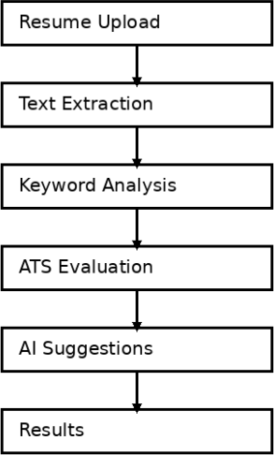

4.2: Resume Document Architecture

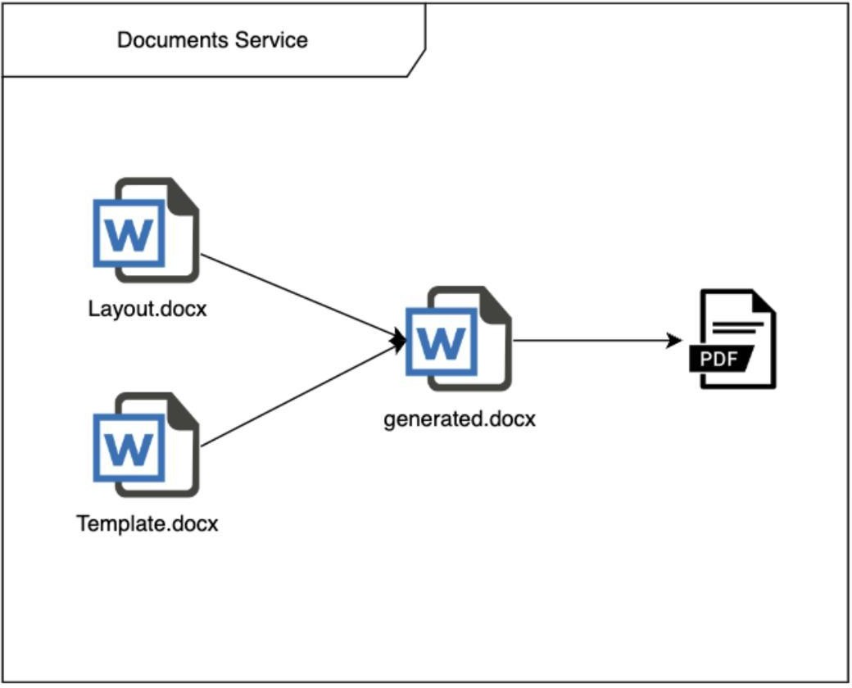

Figure 4.3 : Resume Document Generation and PDF Conversion Process

Advantages of Modular Architecture

The modular architecture provides several advantages:
- Easy maintenance
- Better scalability
- Faster debugging
- Independent module updates
- Improved performance
- Simplified future enhancements
The modular design also improves reliability and flexibility of the system.

Conclusion

This chapter discussed the various modules and components of the AI-based Resume Analyzer and Builder system. Each module performs a specific function and contributes to the overall functionality of the application. The frontend interface ensures smooth user interaction, while the backend processing module handles resume parsing, analysis, ATS evaluation, and resume generation. AI and NLP techniques improve the effectiveness of resume analysis and professional resume creation. The modular architecture ensures scalability, maintainability, and future extensibility of the system.

CHAPTER 5: RESULTS AND DISCUSSION

Introduction

This chapter presents the results obtained from the implementation and testing of the AI-based Resume Analyzer and Builder system. The main objective of this chapter is to evaluate the performance, efficiency, and functionality of the proposed application. Different modules such as resume parsing, ATS evaluation, job description matching, AI-based content enhancement, and resume generation are tested using multiple resumes and job descriptions. The results demonstrate how effectively the system analyzes resumes, calculates matching scores, generates ATS compatibility reports, and produces professional resumes.

The chapter also discusses the behavior of the system under different conditions and analyzes the accuracy of generated outputs. Screenshots, tables, and performance observations are included to provide a clear understanding of the working process and effectiveness of the application. The evaluation process helps identify the strengths, limitations, and possible future improvements of the proposed system.

System Testing Environment

    - Resume Analysis and ATS Evaluation Testing

The resume upload functionality was tested using multiple file formats including PDF, DOCX, and TXT. The system successfully validated supported formats and rejected unsupported files. Uploaded resumes were processed without errors, demonstrating the reliability of the file-handling module.
The text extraction module was tested with resumes containing different layouts and formatting styles. The system accurately extracted textual information such as:
      - Skills
      - Education
      - Experience
      - Certifications
      - Projects

Resume Generation Testing

The resume builder module was tested using structured input data provided by users. The system successfully generated professional resumes in PDF and DOCX formats. The generated resumes maintained proper formatting and readability.

TABLE 5.1: Functional Testing Results

Module | Test Status | Result
Resume Upload | Passed | Successful Upload
Text Extraction | Passed | Accurate Extraction
ATS Evaluation | Passed | Correct Score Generation
Job Matching | Passed | Accurate Matching
Resume Generation | Passed | PDF/DOCX Generated

  - User Interface Results

Home Page

The home page provides an introduction to the application and navigation to different modules such as resume upload and resume builder. The interface is designed to be clean, responsive, and user- friendly.

Resume Upload Page

The resume upload page allows users to upload resumes and enter job descriptions for analysis. Proper validation messages are displayed for unsupported formats.

Result Page

The result page displays:
      - ATS score
      - Matching percentage
      - AI-generated suggestions
      - Download links
The results are presented in a structured and readable format.

Resume Builder Page

The resume builder page collects structured user information and generates professional resumes automatically. The interface simplifies resume creation for users.

Resume Parsing Results

The resume parsing module successfully extracts textual information from resumes uploaded in PDF, DOCX, and TXT formats. The extracted content includes personal information, educational qualifications, technical skills, projects, certifications, and work experience. The text extraction process accurately converts unstructured resume data into machine-readable text suitable for further analysis.

The parsing mechanism effectively handles different resume structures and formats while maintaining extraction accuracy. The extracted data is used for keyword analysis, ATS evaluation, and resume-job matching processes. The results demonstrate that the system performs reliable text extraction for multiple resume formats.

ATS Score Results

The ATS evaluation module successfully generates compatibility scores based on resume formatting, keyword relevance, and structural organization. Resumes containing relevant technical skills, industry-standard keywords, and proper formatting received higher ATS scores compared to resumes with missing information or poor formatting.

The generated ATS scores help users identify weaknesses in their resumes and improve them according to recruitment system requirements. The evaluation process also highlights missing keywords and formatting issues that may affect recruitment screening performance.

Job Description Matching Results

The job description matching module compares resume content with job descriptions provided by users and generates matching percentages based on skill relevance and keyword similarity. The system successfully identifies matching technical skills, educational qualifications, and experience- related keywords between resumes and job descriptions.

The generated matching scores help users understand how well their resumes align with specific job roles. The system also identifies missing skills and weak areas that require improvement. This feature assists candidates in optimizing resumes according to industry requirements and job expectations.

System Output Screens
5.3.5 Results

The proposed AI-based Resume Analyzer and Builder system successfully performs resume analysis, ATS evaluation, job description matching, and professional resume generation. The system was tested using different resume formats such as PDF, DOCX, and TXT to evaluate its functionality and performance. The uploaded resumes were processed accurately, and meaningful analysis results were generated for users.

The resume analysis module successfully extracted important information such as technical skills, educational qualifications, certifications, projects, and work experience from uploaded resumes. The Natural Language Processing techniques used in the system effectively identified relevant keywords and evaluated resume content according to job requirements.

The ATS evaluation feature generated compatibility scores based on resume formatting, keyword optimization, and content structure. The generated scores helped users identify weaknesses in their resumes and improve them according to industry standards. The system also highlighted missing skills and suggested improvements for better alignment with job descriptions.

The job description matching functionality compared resumes with user-provided job descriptions and generated matching percentages based on keyword relevance and content similarity. This feature helped users understand how well their resumes matched specific job roles and identify areas for improvement.

The AI-based suggestion module improved resume quality by generating professional recommendations, grammar corrections, and formatting suggestions. Weak sections in resumes were enhanced using professional wording and optimized content structure. This improved the overall readability and effectiveness of resumes.

The resume builder module successfully generated professional resumes using structured user inputs such as personal information, education, skills, projects, and work experience. The generated resumes were converted into downloadable PDF and DOCX formats, providing flexibility and convenience for users during job applications.

Overall, the results obtained during testing demonstrate that the proposed system performs effectively and fulfills the primary objectives of the project. The application provides a user-friendly and intelligent platform for resume optimization and recruitment support.
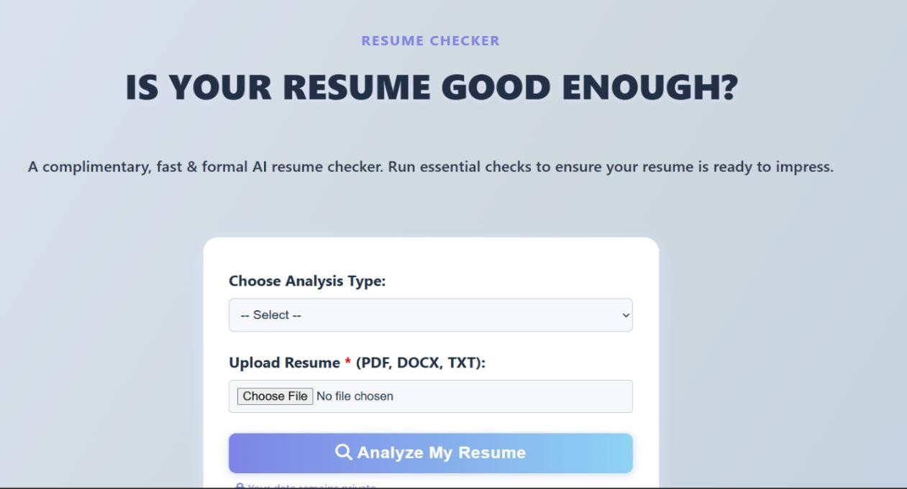

Figure 5.1: Resume Upload and Analysis Interface

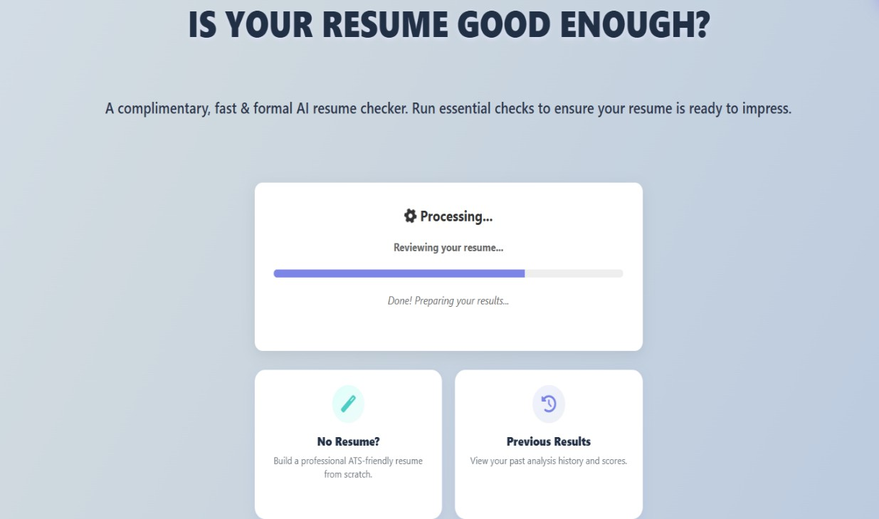

Figure 5.2: Resume Processing and Analysis Result Interface

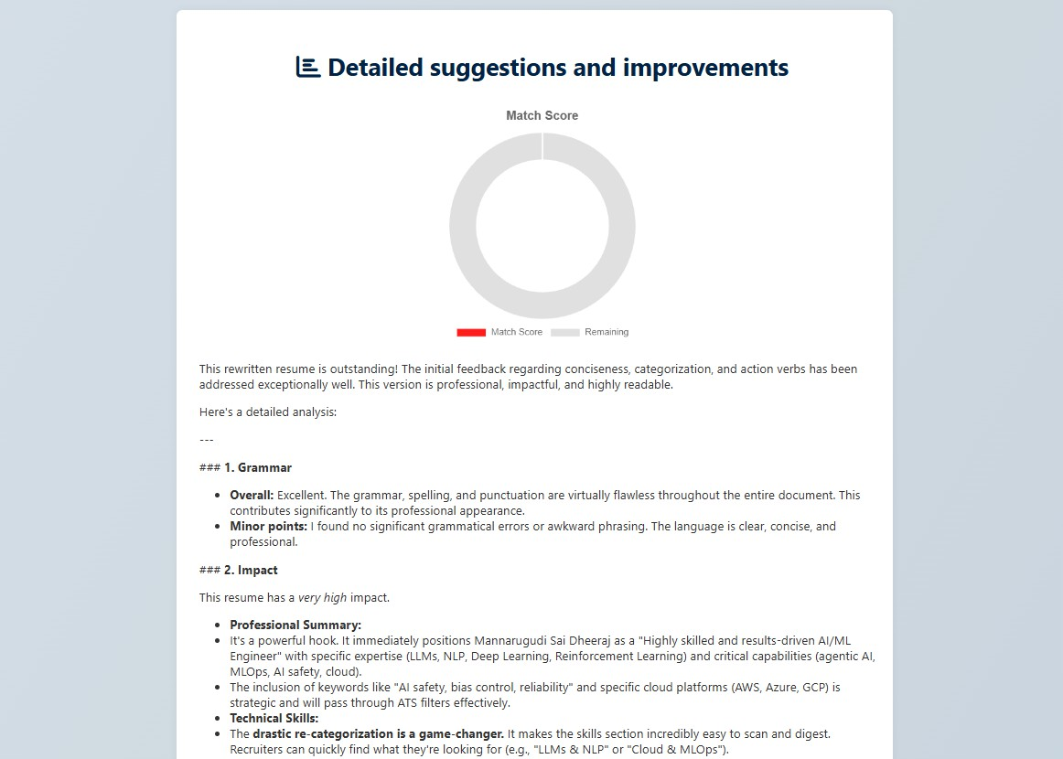

Figure 5.3: AI-Based Resume Analysis and Suggestion Interface

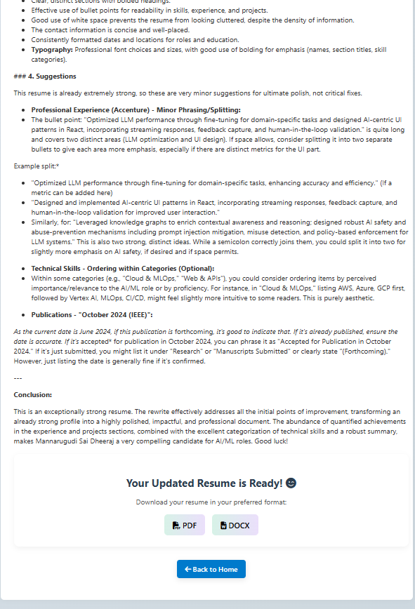

Figure 5.4: Updated Resume Download Interface

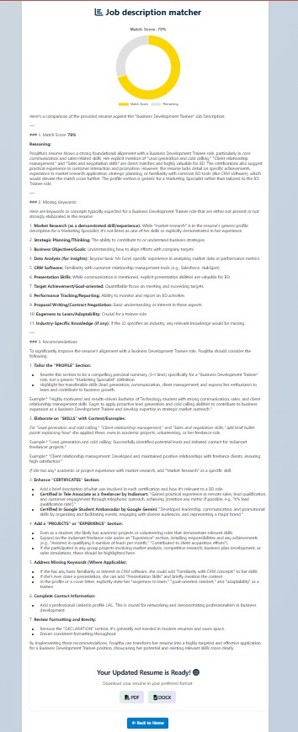

Figure 5.5: Job Description Matching and Resume Evaluation Interface

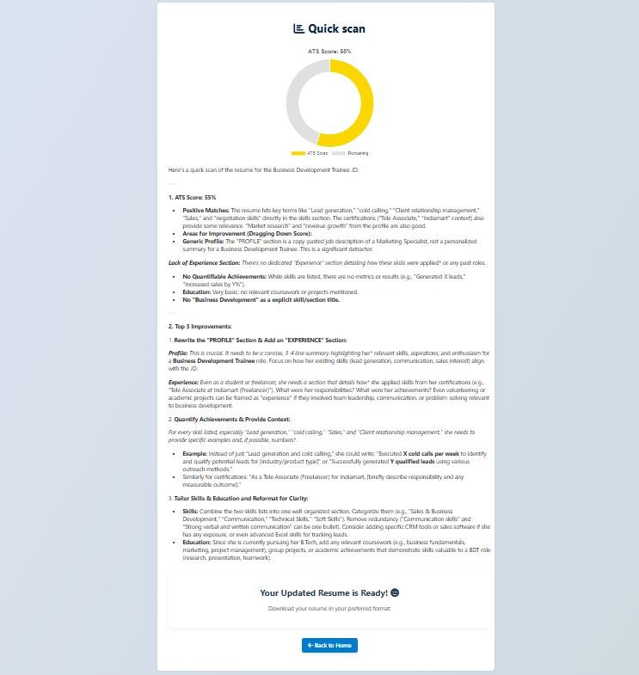

Figure 5.6: Quick ATS Resume Scan Result Interface

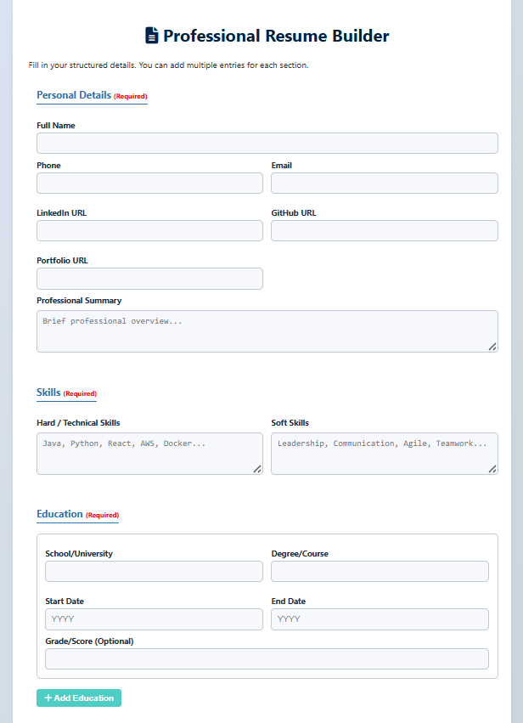

Figure 5.7: Professional Resume Builder Interface

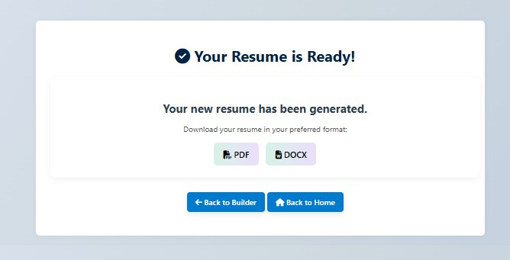

Figure 5.8: Resume Generation and Download Interface

Performance Analysis
    - Processing Speed
The system processes resumes quickly due to optimized backend processing and FastAPI integration. Average response time for resume analysis was observed to be within a few seconds depending on file size and complexity.

Accuracy of Analysis
The NLP-based analysis module successfully identified relevant keywords and generated meaningful ATS scores. The semantic matching approach improved job description matching accuracy compared to basic keyword-only systems.
TABLE 5.2: System Performance Analysis

Parameter | Performance
Resume Processing Speed | High
ATS Score Accuracy | Good
Job Matching Accuracy | High
File Handling Reliability | Excellent
Resume Generation Speed | Fast

TABLE 5.3: Comparison with Existing Systems

Feature | Existing Systems | Proposed System
Resume Analysis | Available | Advanced AI-Based
ATS Score Generation | Limited | Detailed
Resume Builder | Separate Tools | Integrated
Job Matching | Basic | Semantic Matching
PDF/DOCX Generation | Partial | Fully Supported
AI Suggestions | Limited | Advanced Suggestions

Advantages and Limitations of the System
The proposed system provides several advantages:
- Automated resume analysis
- Improved ATS compatibility
- Integrated resume builder
- Fast and scalable processing
- User-friendly interface
- Support for multiple file formats
These features improve resume quality and simplify the job application process for users. Although the system performs effectively, certain limitations still exist:
- No permanent database storage
- Dependency on AI-generated content quality
These limitations can be addressed in future enhancements.

Future Enhancements
Future improvements for the system may include:
- Integration with cloud databases
- Advanced AI-based scoring models
- Real-time job recommendation systems
- User authentication and profile management
- More resume templates and customization options
- Integration with recruitment platforms
These enhancements can further improve the functionality and usability of the system.

CHAPTER 6: CONCLUSION AND FUTURE SCOPE

6.1 Conclusion
The AI-based Resume Analyzer and Builder system successfully demonstrates the application of Artificial Intelligence and Natural Language Processing techniques in modern recruitment and resume management processes. The system was designed and implemented as a web-based application capable of analyzing resumes, evaluating ATS compatibility, matching resumes with job descriptions, and generating professional resumes automatically. The integration of multiple functionalities into a single platform provides a comprehensive solution for job seekers and improves the overall effectiveness of the resume preparation process.

One of the major achievements of the proposed system is its ability to process resumes in multiple formats such as PDF, DOCX, and TXT. The resume parsing and text extraction modules effectively convert unstructured resume data into machine-readable text, enabling further analysis using NLP techniques. The preprocessing mechanisms improve the accuracy and reliability of extracted information by removing unnecessary data and organizing textual content into a structured format.
The system also successfully performs job description matching by comparing resume content with job requirements using keyword analysis and semantic similarity techniques. The generated matching score helps users understand how well their resumes align with a specific job role. This feature assists candidates in identifying missing skills and improving their resumes according to industry requirements.

Another important contribution of the system is ATS compatibility evaluation. Modern recruitment systems often reject resumes due to poor formatting or missing keywords, even when candidates possess relevant qualifications. The proposed system evaluates resumes based on ATS standards and generates compatibility scores along with improvement suggestions. This functionality helps users optimize their resumes and improve their chances of passing automated recruitment filters.
The AI-based content enhancement module further improves resume quality by generating professional suggestions, correcting grammar, optimizing keywords, and improving formatting. The generated recommendations help users create resumes that are more professional, readable, and industry-standard. This feature is particularly useful for students and fresh graduates who may not have prior experience in preparing effective resumes.
The resume builder module successfully generates professional resumes from structured user input.

Users can enter personal details, education, projects, skills, certifications, and work experience through a user-friendly interface. The collected information is formatted into professional resume templates and converted into downloadable PDF and DOCX files. This functionality simplifies resume creation and provides flexibility for users during job applications.
From a technical perspective, the Fast API framework provided efficient backend processing and smooth communication between frontend and backend components. The modular architecture improved scalability, maintainability, and system performance. Different modules such as file handling, NLP processing, AI analysis, ATS evaluation, and document generation worked together efficiently to provide reliable outputs.

The results obtained during system testing demonstrate that the proposed application performs effectively in terms of resume analysis accuracy, ATS score generation, job matching, and resume generation. The system successfully achieved the objectives defined at the beginning of the project and provides a practical solution for improving resume quality and recruitment readiness.

Overall, the AI-based Resume Analyzer and Builder system provides an intelligent, scalable, and user-friendly platform that assists users in creating optimized and professional resumes.

The project demonstrates how AI and NLP technologies can be integrated into recruitment support systems to simplify resume evaluation and improve employment opportunities for job seekers.

6.3 Future Scope

Although the proposed system performs effectively and fulfills its primary objectives, several enhancements can be implemented in the future to improve functionality, scalability, and user experience. As Artificial Intelligence and recruitment technologies continue to evolve, the system can be extended with additional features and advanced capabilities.
One of the major future enhancements is the integration of a database management system for permanent storage of user data, analysis reports, and generated resumes. Currently, the system stores user history temporarily using session management techniques. By integrating databases such as MySQL or MongoDB, the application can provide secure user accounts, long-term storage, and personalized user experiences.
Another important improvement is the integration of advanced machine learning and deep learning models for more accurate semantic analysis and job matching. Modern transformer-based NLP models such as BERT and GPT can improve contextual understanding of resumes and job descriptions. This would enhance matching accuracy and provide more intelligent recommendations for users.
The system can also be extended by integrating real-time job recommendation features. By connecting the application with online job portals and APIs, users can receive job suggestions based on their resume content and skills. This would transform the system into a complete career support platform rather than only a resume analysis tool.

Future versions of the application may include advanced ATS simulation features that replicate the behavior of real recruitment systems more accurately. This would help users understand how different ATS platforms evaluate resumes and provide more targeted optimization suggestions.
Another enhancement involves adding multiple resume templates and customization options. Users may be allowed to select different professional designs, layouts, and color schemes according to their career domain and preferences. This would improve personalization and make the generated resumes more attractive and versatile.

Cloud deployment and distributed processing can also improve scalability and performance for large- scale usage. Deploying the system on cloud platforms such as AWS, Google Cloud, or Microsoft Azure would allow the application to handle a larger number of users efficiently and support real- time processing with reduced latency.

The integration of multilingual support is another valuable future enhancement. Currently, the system mainly processes resumes in English. Adding support for multiple languages would increase accessibility and usability for users from different regions and backgrounds.User authentication and profile management systems can further improve security and personalization. Registered users could store multiple resumes, track progress over time, and receive customized suggestions based on their career interests and previous analyses.Future research may also focus on integrating interview preparation features such as AI-generated interview questions, skill gap analysis, and career guidance systems. This would provide users with complete recruitment preparation support within a single platform.

In conclusion, the future scope of the AI-based Resume Analyzer and Builder system is extensive. With advancements in AI, cloud computing, and NLP technologies, the system can evolve into a
more intelligent, scalable, and feature-rich recruitment support platform that provides comprehensive career assistance to users worldwide.

REFERENCES

- Fast API Documentation, “Fast API Framework Documentation,” Available:
https://fastapi.tiangolo.com/
- Python Software Foundation, “Python Documentation,” Available: https://docs.python.org/
- NLTK Documentation, “Natural Language Toolkit,” Available: https://www.nltk.org/
- Spa Cy Documentation, “Industrial-Strength Natural Language Processing,” Available:
https://spacy.io/
- Resume Parsing Using Natural Language Processing Techniques, International Journal of Computer Applications, 2021.
- Applicant Tracking Systems and Automated Recruitment Processes, Journal of Information Technology and Management, 2020.
- Deep Learning Approaches for Resume Classification and Job Matching, IEEE Research Publications, 2022.
- AI-Based Recruitment Systems Using NLP and Machine Learning, Springer Publications, 2021.
- PDF and DOCX File Processing in Python, Python Libraries Documentation.
- Web Development Using Fast API and Jinja2 Templates, Technical Documentation Series, 2023.
- BERT: Pre-training of Deep Bidirectional Transformers for Language Understanding, Google Research Publications.
- Natural Language Processing with Python, Steven Bird, Ewan Klein, and Edward Loper,
O’Reilly Media.
- Machine Learning Applications in Recruitment Systems, International Journal of Artificial Intelligence Research, 2022.
- Resume Optimization and ATS Compatibility Techniques, Recruitment Technology Journal, 2021.
- Modern Web Application Development Using Python Frameworks, International Journal of Web Engineering, 2023.

BIOGRAPHIES

Mrs. S. CHANDANA KRISHNA is the Assistant Professor of the Department of Computer Science and Engineering (Artificial Intelligence) at Audisankara College of Engineering & Technology, Gudur, Andhra Pradesh, India. With extensive experience in teaching and research, her areas of expertise include artificial intelligence, machine learning, and data analytics. She can be reached at

Mannarugudi Poojitha is a student in the Department of Computer Science and Engineering (Artificial Intelligence) at Audisankara College of Engineering & Technology, Gudur, Andhra Pradesh, India. Her research interests focus on artificial intelligence, machine learning, and their applications in real-world systems. She can be reached at poojithamannarugudi2004@gmail.com

Monika.V is a student in the Department of Computer Science and Engineering (Artificial Intelligence) at Audisankara College of Engineering & Technology, Gudur, Andhra Pradesh, India. Her areas of interest include AI, machine learning, and data science, with a particular focus on the development of intelligent systems. She can be reached at monisparrow2623@gmail.com

Kommireddy Vinay Kumar Reddy is a student in the Department of Computer Science and Engineering (Artificial Intelligence) at Audisankara College of Engineering & Technology, Gudur, Andhra Pradesh, India. His research interests include artificial intelligence, deep learning,and natural language processing.He can be reached at vinaykumarreddy215@gmail.com

Mopuru Sai Krishna is a student in the Department of Computer Science and Engineering (Artificial Intelligence) at Audisankara College of Engineering & Technology, Gudur, Andhra Pradesh, India. His academic focus includes artificial intelligence and its various applications in solving complex problems. He can be reached at saikrishnamopuru2003@gmail.com

